**St Andrews Research Culture Survey**

**Comparison Report 2021-2023**

**June 2024**

**Authors:**

Dr. Anne-Marie Craig

Prof. Julie Harris

Prof. Ruth Woodfield

**Contents**

Executive Summary 3

1.0 Introduction 6

1.1 Developments in Research Culture across the academic research ecosystem 7

1.2 Context of University of St Andrews 8

1.3 The 2023 Survey Design and Participation 8

1.4 Data Analysis and Reporting 9

2.0 Findings by Theme 10

2.1 Collegiality, Collaboration and Interdisciplinarity 10

2.2 Equality Diversity and Inclusion 13

2.3 Research Integrity 15

2.4 Mental Health & Wellbeing 16

2.6 Work-Life Balance 20

2.7 Research Satisfaction 21

2.8 Leadership 22

2.9 Sustainability 24

3.0 Conclusions and Next Steps 25

References 26

# **Executive Summary**

This report outlines findings from our Research Culture survey that was repeated in March 2023, following our earlier survey in March 2021. Our aim was to explore the trajectory of research culture at University of St Andrews (UStA) over the two-year period. The 2023 survey adopted the same design of the previous survey, exploring the same themes with some small additions [1] to highlight which aspects of research culture have been maintained in the eyes of our community, and which have changed. Similarities and differences between the participant populations in 2021 and 2023 are described, before discussing findings in more detail and by topic.

**Participant Population**

As is expected for a repeat survey, fewer people participated in 2023 (291), compared with 2021 (670). The pattern of participation was similar in terms of ethnicity, gender age range, discipline and job family.

**What Did We Find?**

Both 2021 and 2023 survey covered similar topics, with the 2023 having an additional question on sustainability. Overall, the survey results were remarkably similar across the two periods, suggesting that the issues raised are systemic at UStA and are not driven by specific contextual elements during the two periods (e.g., the Covid-19 pandemic, industrial action). Key findings for each topic are summarised below.

**Collegiality, Collaboration and Interdisciplinarity:**

The significant variations in experience between different demographic groups identified in the 2021 survey remained present in the 2023 survey data.

Both surveys indicated a lack of confidence that collegiality was recognised or rewarded by the UStA. Participants in both surveys expressed a need to clarify and define collegial behaviors.

Difficulties securing finance, support and recognition for interdisciplinary projects was a theme in both the 2021 and 2023 survey results. In 2023, the negative impact of the REF submission on interdisciplinary working was commented on, but many participants in 2023 also commented on the added value of interdisciplinary working in relation to quality of research and personal satisfaction, and offered insights on how interdisciplinary projects could be moved forward.

**Equality, Diversity and Inclusion (EDI):**

Both surveys indicated there were concerns around the structures and processes within the University not achieving their intended outcomes in relation to EDI. In the 2023 survey, participants recognised there were more efforts to address issues relating to disabilities, mental health and wellbeing, but identified a need for further work on these areas.

Flexible working policies and feelings of inclusion are not perceived as positively in the 2023 survey, with fewer people feeling EDI efforts are successful and more people identifying incidences of discrimination in their workplace.

In the 2023 survey, men commented more negatively about EDI generally, while women expressed more concerns about the current policies and actions not creating enough impact on EDI.

**Research Integrity:**

In both the 2021 and 2023 surveys participants felt processes to ensure research integrity within UStA were successful. There were, however, concerns around how research contributions are acknowledged. In the 2023 survey additional concerns were expressed about the role and impact of research funders on how research is conducted.

**Mental Health and Wellbeing:**

In the 2023 survey, mental health support and workload were topics commented on most frequently, with research and teaching and education-focused participants mentioning time pressures and pressure of workload more than other groups. The negative impact of precarious work contracts was also highlighted.

**Bullying and Harassment**

The difficulties of addressing issues of bullying and harassment were similar for both 2021 and 2023 surveys.

**Work-Life Balance:**

In the 2021 survey, participants from all job families said they felt under pressure to deliver against work expectations from the UStA. In the 2023 survey, older participants (50+) expressed more agency in relation to their work-life balance, making choices around how they engaged with the University. Younger participants were less positive in the 2023 survey, some making references to looking for more sustainable career options outwith a university setting.

In the 2023 survey, it was clear that Covid-19 has had long-term impacts on work-life balance. The 2021 survey participants felt that during the pandemic teaching was prioritised over research. In the 2023 survey participants felt that UStA commitment remains with teaching, with research pushed behind teaching in terms of the University’s commitments and resources.

**Research Satisfaction:**

In both the 2021 and 2023 surveys, a lack of time for research was highlighted as the biggest challenge to research satisfaction.

**Leadership:**

The 2023 survey produced less positive comments around the topic of leadership than in the 2021 survey. The lack of diversity and a subsequent feeling of distance between senior leadership and the rest of UStA was referenced in similar ways in both surveys. Participants in the 2023 survey made more references to a lack of training for Heads of School and research supervisors, with all groups in the 2023 survey suggesting training for leadership across the UStA.

**Sustainability:**

This was an additional open question in the 2023 survey. Sustainability was mentioned by one participant in the 2021 survey. There were 36 responses to the open question on sustainability in 2023. Younger people (<50 yrs.) felt the University shows a lack of commitment to sustainability by not implementing sustainable research practices. Some older researchers (50+ yrs.) felt that air travel and travel generally is an essential part of research while younger participants felt that the propensity to travel should be reduced, and that researchers should be making more effective use of Teams and other digital platforms.

**Constants across 2021 and 2023 Surveys**

Positive things about research culture that are present in both 2021 and 2023 include perceptions that policies related to research integrity continue to work well and are embedded in our research culture, and the positive and life affirming impact of the research endeavour.

Concerns around the negative impacts of short-term contracts received the most ’agreed’ responses across both surveys. Levels of concerns around recognition and reward within promotion structures across all job families and around long-hours working remained unchanged across both surveys.

**Differences across 2021 and 2023 Surveys**

Figure 1 and Figure 2 demonstrate how the qualitative findings from both surveys cover many of the same themes. They also provide evidence that the 2023 survey responses were more negative about research culture.

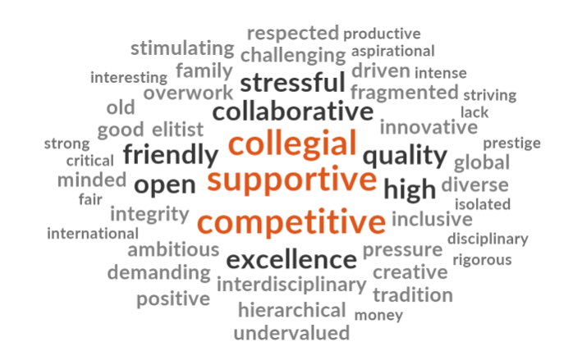

*Figure 1: Frequency of top 50 words participants used to describe research culture in St Andrews in 2021 survey*

*Figure 2: Frequency of top 50 words participants used to describe research culture in St Andrews in 2023 survey*

The sections below offer a more detailed exploration of both the quantitative and qualitative aspects of our data.

# **1.0 Introduction**

The following section describes changes occurring across the research culture context between 2021 when the first survey was conducted and the completion of the second survey in 2023, before comparing differences in structure and participation levels for each survey.

## **1.1 Developments in research culture across the academic research ecosystem**

Since the previous Survey Report in 2021 there has been a widening recognition of the importance of research culture within the HE sector. Discussions of research culture have moved beyond integrity, open research and responsible use of metrics, to include discussions around recognition and reward (Hossini, Gordijn, Wafford and Holmes 2023; UKRN Open and Responsible Research reward and Recognition Project (OR4)) and considerations of how Higher Education Institutions (HEI) can support the research workforce (Carusi 2024; Russell Group 2021).

The inclusion of People, Culture and Environment (PCE) indicators as part of the submissions to Research Excellence Framework 2029 (REF), the system for assessing the quality of research in UK’s HEI, along with the increased funding for research culture from Research England (2022) and the Wellcome Trust (2023), signal an growing awareness of the importance of culture on research quality. Further evidence of the increasing importance of research culture are the instigation of University of Warwick’s Centre for Research Culture and the first International Research Culture Conference in 2023. Internationally, institutions and funding organisations are working to identify indicators of positive research culture. Within the UK a number of actors, including the Research-on-Research Institute (RoRI), UK Research and Innovation (UKRI), UK Research Network (UKRN), and the Coalition on Advancing Research Assessment (CoARA) are investing resources that support changes in behaviours and expectations to increase diversity and recognition within academia, moving beyond the traditional impression of the ‘guild academic’ (Macfarlane and Jefferson 2022) to include a broader spectrum of individuals involved in the research endeavour in academia (see [UKRI Future Leaders Development Network](https://www.bing.com/ck/a?!&&p=aca785b00c50ca41JmltdHM9MTcxNjE2MzIwMCZpZ3VpZD0zNWE0ZTNkNS0zM2Q5LTZkZDgtMzg2NS1mMmY4MzI4MTZjOTAmaW5zaWQ9NTIxOA&ptn=3&ver=2&hsh=3&fclid=35a4e3d5-33d9-6dd8-3865-f2f832816c90&psq=future+leaders+development+netwrok&u=a1aHR0cHM6Ly93d3cuZmxmZGV2bmV0LmNvbS8&ntb=1); [UKRN Catalogue of Institutional Research Culture Projects](https://www.bing.com/ck/a?!&&p=cbde385f151fd576JmltdHM9MTcxNjE2MzIwMCZpZ3VpZD0zNWE0ZTNkNS0zM2Q5LTZkZDgtMzg2NS1mMmY4MzI4MTZjOTAmaW5zaWQ9NTI4NQ&ptn=3&ver=2&hsh=3&fclid=35a4e3d5-33d9-6dd8-3865-f2f832816c90&psq=UKRN+Catalogue+of+Institutional+Research+culture+projects&u=a1aHR0cHM6Ly9vc2YuaW8vdmJnMzUvIyE&ntb=1); [Leeds University Research Uncovered podcast](https://research-culture.captivate.fm/);  [University of Glasgow The Auditorium](https://www.bing.com/ck/a?!&&p=c3057358d00dd85cJmltdHM9MTcxNjE2MzIwMCZpZ3VpZD0zNWE0ZTNkNS0zM2Q5LTZkZDgtMzg2NS1mMmY4MzI4MTZjOTAmaW5zaWQ9NTIwNw&ptn=3&ver=2&hsh=3&fclid=35a4e3d5-33d9-6dd8-3865-f2f832816c90&psq=University+of+glasgo+w+the+Auditorium&u=a1aHR0cHM6Ly90aGVhdWRpdG9yaXVtLmJsb2cv&ntb=1); [Warwick University Technicians Commitment](https://www.bing.com/ck/a?!&&p=58f970bce0710340JmltdHM9MTcxNjE2MzIwMCZpZ3VpZD0zNWE0ZTNkNS0zM2Q5LTZkZDgtMzg2NS1mMmY4MzI4MTZjOTAmaW5zaWQ9NTIxNA&ptn=3&ver=2&hsh=3&fclid=35a4e3d5-33d9-6dd8-3865-f2f832816c90&psq=warwick+university+technicians+comittment&u=a1aHR0cHM6Ly93YXJ3aWNrLmFjLnVrL3Jlc2VhcmNoL3RlY2huaWNpYW5zL3VwZGF0ZTIwMjIv&ntb=1)).

## **1.2 Context of University of St Andrews**

The 2021 Research Culture Survey emerged from the work of the Research Culture Team who prepared a Research Culture Vision in 2020. This work aligned with the University’s first People's Strategy, published in 2020.

Since 2021 there have been changes to key personnel involved in research culture (AVP Diversity, the Master, and Head of Research and Innovation Services); a long-term industrial dispute involving research and teaching personnel; the merging of Management, Finance and Economics to form a new Business School and the launch of a new staff training portal. Findings from REF21 announced 80% of research from UStA was internationally excellent. St Andrews was named top UK University by both Times Higher Education and Guardian university rankings 2024.

The 2023 Research Culture Survey coincided with the refresh of the People’s Strategy (2023-2027) that states the ambitions of attracting, developing, valuing, supporting, leading and planning for people. This indicates the University’s ongoing commitment to address areas of interest and concern expressed in the responses to the Research Culture Surveys.

## **1.3 The 2023 Survey Design and Participation**

## 

The survey questions were almost identical across the 2 years. The 2021 survey made no specific mention of disability. In the 2023 survey, Q22 Mental Health & Wellbeing was adapted to include a question on disability. A similar number of comments mentioning disability appeared across both surveys.

The 2021 survey included a question on the impact of the Covid pandemic. In 2023 it was removed and replaced with a question on sustainability.

Quantitative data were directly compared to identify any significant differences in response. We also interrogated the qualitative data with the aim of identifying specific new or changed issues. The qualitative findings from both 2021 and 2023 surveys were broadly similar across the nine key themes identified in the 2021 survey, although comments from the 2023 participants were more negative than in 2021. The themes were: collegiality, collaboration and interdisciplinarity, career development and structure, equality, diversity & inclusion (EDI), research integrity, bullying & harassment, mental health & wellbeing, work-life balance, research satisfaction and leadership). The additional theme of sustainability was added to the 2023 survey.

As is expected for a repeat survey, fewer people participated in 2023 (291), compared with 2021 (670). The pattern of participation was similar in terms of ethnicity, gender age range, discipline and job family. Figures 3 and 4 below show proportion of participants across (a) job family, (b) gender, (c) age, (d) academic discipline, (e) ethnicity.

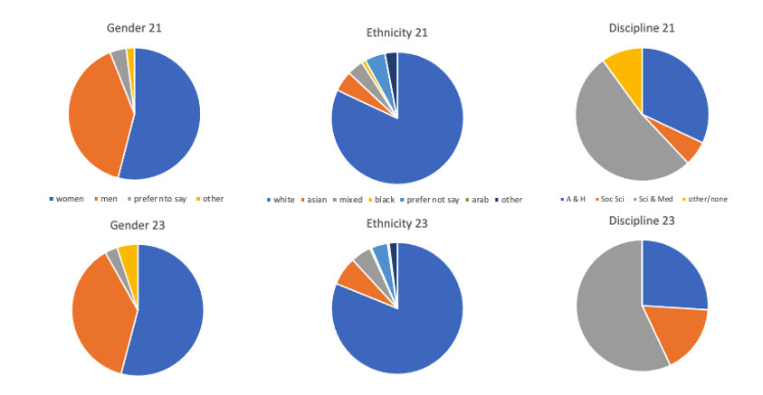

***Figure 3: Comparison of Survey Participants’ Gender, Ethnicity and Discipline 2021-23***

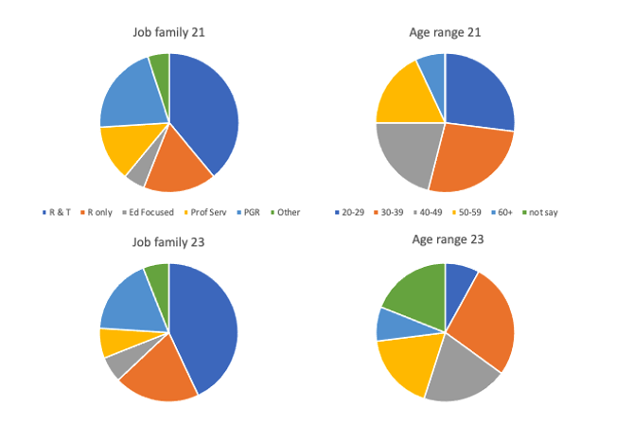

***Figure 4: Comparison of Survey Participants’ Job Family and Age Range 2021-23***

## **1.4 Data Analysis and Reporting**

For the 2023 survey, we employed the same analytical approach as the 2021 survey, testing whether any themes linked specific demographic characteristics to the closed-ended and open-ended question responses. The responses to closed-ended questions were based on a 5-point scale (1 = strongly disagree, 2 = disagree, 3 = neither agree nor disagree, 4 = agree, and 5 = strongly agree). An “I don’t know” option was included, in case the question was not relevant to some participants. This response was coded zero and was excluded from the analysis. Participants could also leave any question unanswered.

Both quantitative and qualitative data were further explored. Quantitative data were used to summarise key results, and to provide pointers to explore the qualitative data. For each question, we tested for significant differences across demographic characteristics (using uncorrected t-tests, p<0.05 defined as the level at which a result was significant), and we looked for questions that resulted in particularly high or low scores. The 2023 survey provided more noticeable differences between demographic groups (age and gender) which are discussed in detail under each theme. This report includes a variety of charts and graphs to illustrate the major points delivered by the quantitative data.

In addition to the quantitative information, the 291 respondents to the survey provided over 1700 individual comments. Analysis of the qualitative data, conducted over multiple cycles of coding within NVivo software (QSR International Pty (Ltd.), 2020) uncovered similar themes to the 2021 survey. These themes are discussed in sections 2.1-2.5 below.

# **2.0 Findings by Theme**

Findings are graphed by response, showing a sum of ‘strongly agree’ and ‘agree’ responses as ‘agree’ and ‘strongly disagree’ and ‘disagree’ responses as ‘disagree’. Statistically significantly differences (p<0.05) between the two years data are shown by a cross symbol on each graph.

**2.1 Collegiality, Collaboration and Interdisciplinarity**

People’s experience of collegiality, including their personal experience, encouragement and awareness of how the University recognises collegiality were very similar across the two years, as were their views on competition (figure 5). The importance of both lone scholarship and collaboration were reported across both time periods, with no significant differences found (figure 6).

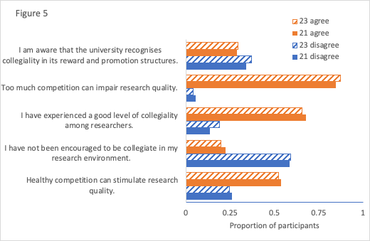

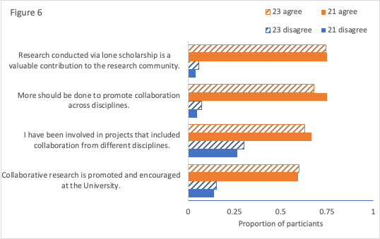

Both surveys show a lack of confidence that collegiality is appropriately recognised or rewarded by the UStA and participants in both surveys expressed a need to clarify and define collegial behaviors.

Some illustrative comments across the two years follow below. Collegiality is viewed negatively by some, suggesting that the UStA approach to encouraging and rewarding good citizenship could be reviewed and further refined.

**2021**

*“Collegial people get exploited far too much by self-interested professors who can't be bothered with teaching, grant writing, student supervision or participating in committees. Several of my more collegiate colleagues have been marked as "mugs" and tend to get all of the non-research tasks dumped on them (or volunteer when the room goes quiet and everyone looks at them by default).”*

**Undisclosed Gender, Undisclosed Ethnicity, Research & Teaching, AD**[2]

*“Collegiality is important for research progress but might not benefit the individual. I have been told that I collaborate too much and should focus on first/last authorship. One of my priorities is to ensure the career progression of members of my team, and I think I go out of my way to help others. I do it because it is important to me. But I do not think there is a mechanism to recognize these efforts.”*

**Woman, White, 30-39, Research-Focused, SM**

***2023***

*“There are colleagues who seem to demand, and get, teaching discounts to help them do more or less anything they deem important. They then proceed to do these important things, which are terrifically impressive and facilitate them in advancing in their careers. Other people pick up whatever it was they didn't feel like doing, which takes their time away from pursuing their own interests, and they don't get cut the same slack on relief etc. It's a lack of transparency, but it's noticeable that it's always the same people, and they're not even necessarily the best researchers, just the pushiest. When I'm forced to think about this, I feel that a shorter word for someone who's collegiate is mug.”*

**Man, White, 40-49, Education-Focused, AD**

Difficulties securing finance, support and recognition for interdisciplinary projects was a theme in both 2021 and 2023. The negative impact of the REF submission on interdisciplinary working was a theme within the 2023 survey. However, many participants in 2023 commented on the added value of interdisciplinary working in relation to quality of research and personal satisfaction and offered insights on how interdisciplinary projects could be moved forward.

**2021**

*“I have tried on numerous occasions to collaborate outside* [redacted School name] *but with little success. The competition within the University is such that if there is not a significant overlap of research topic in different Schools then there is no funding, and nobody is willing to help other researchers for "free" even if it is intellectually stimulating.”*

**Man, undisclosed ethnicity, 40-49, Other, SM**

**2023**

*“I'm involved in an interdisciplinary project with a colleague from another school, and finding meaningful financial support has been incredibly hard. It was a shame that the institution retired the interdisciplinary PhD scholarships. We applied for a World-Leading scholarship but were unsuccessful and received zero feedback. Now we don't know if it's a case that our proposal was weak in an area that the University finds worthwhile, or whether we had a strong proposal in a discipline boundary that is a lower priority. We don't really know how to proceed or how to gain support. We've been finding that this project is low priority for both schools and no-one seems to know how to get an interdisciplinary project off the ground. But, on the upside, starting this project was one of the best things that happened to me, professionally, since 2020. Learning from other disciplines is phenomenally valuable, opens doors I didn't know were there and it's just tremendous fun.”*

**Woman, undisclosed ethnicity, 40-49, Education & Research, undisclosed discipline**

*“I have had the privilege of doing individual research and of being part of several teams - a number of which were interdisciplinary. Working as a team undoubtedly enabled me to do research that would not have been possible on my own. That being said, I think when undertaking research as a team a lot of time can be consumed in meetings / just communicating across the people involved. Related to this, the admin just seemed to expand massively! I also think there can be issues in teams with more junior researchers not getting properly credited for the often absolutely vital work that they have done. I think this situation is actually made worse by REF - there is considerable pressure to make sure that research is credited to people who will be included in the REF submission. This means that there are subtle pressures to downplay the contribution of people on short-term contracts and to stress the contribution of permanent staff.”*

**Woman, undisclosed ethnicity, 30-39, Education & Research, undisclosed discipline**

## **2.2 Equality Diversity and Inclusion**

In this theme, there were some significant and potentially concerning differences between the years (Figures 8, 9). Fewer people in 2023 agreed that the University’s EDI policies are improving EDI, fewer feel included as a member of the research community, and more were aware of discrimination in their research environment. The 2023 survey showed clear differences in the way men and women perceived EDI work conducted by the University, with men expressing concerns that EDI initiatives were disruptive while women expressed concerns that not enough changes were being delivered in relation to this agenda.

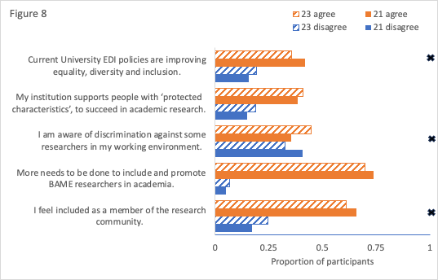

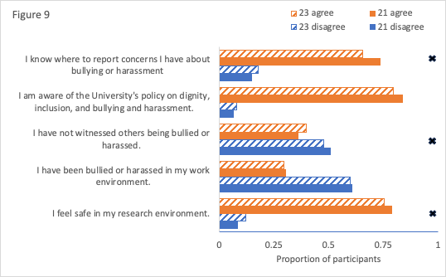

In Both 2021 and 2023 survey participants across all demographic groups suggested the structures and processes in UStA are not achieving the intended outcomes in relation to EDI. In the 2023 survey, men commented more negatively about EDI, while women expressed more concerns about the current policies and actions not creating enough impact on EDI.

**2021**

*“So much of the work on EDI at the institution is superficial, focused on Athena Swan submissions rather than meaningfully and lastingly changing practices and cultures within departments and as an institution. There is a dearth of BAME colleagues in leadership positions. As someone who is not White British/American and not from a privileged socio-economic background, I feel like an outsider in academia generally and at this institution in particular. As ever, socio-economic status, the single greatest vector of difference and inequality in society is all but completely ignored and so little is done to either raise awareness over this issue or to assist students/staff from lower-income backgrounds to excel and progress.”*

**Man, White, 50-59, Education & Research, SM**

**2023**

*“From my perspective, current EDI policies are there to tick boxes and win awards. There is a huge gender problem in my department here, and I see nothing done about it, only secret procedures that no one ever hears about being put in place to get Athena Swan awards. Treatment (and even employment) of BAME staff is dire. My department is so white. There is a huge problem in wanting to employ people who have done degrees at this University, but no one seems to acknowledge the fact that BAME students or those from developing nations cannot afford to do a degree here.”*

**Woman, White, 20-29, Research-focused, SM**

In 2023 fewer people agreed that training opportunities are appropriate for their needs (Figure 7, significant difference indicated by *). Note also that concern about temporary contracts (q3 in the set) delivered the ‘most agreed’ response in the whole survey, with more than 85% of respondent agreeing that short term contracts can put people off a career in academic research.

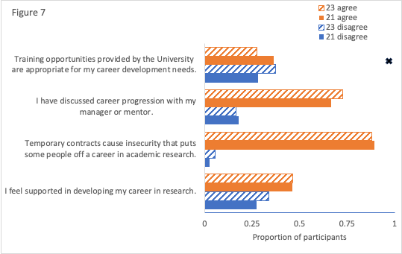

## **2.3 Research Integrity**

In both 2021 and 2023 surveys participants felt there is a good process to ensure research integrity within UStA, but there are concerns around how research contributions are acknowledged (Figure 10).

In the 2023 survey there were additional concerns expressed about the role and impact of research funders on how research is conducted.

**2021**

*“I am aware of several past cases in which there have been failings of research integrity (or accusations of this) through my contribution to the disciplinary process in response to these cases. I believe that these have each been dealt with robustly and fairly, and so I know first-hand from these that the University takes research integrity very seriously.”*

**Man, White, Education & Research, SM**

**2023**

*“The University takes this very seriously and I am in favour of that, even though it has been challenging at times to follow through on the meticulous paperwork required.”*

**Man, White, 50-59, Other job Family, AD**

***“****Given that many research teams and collaborations span across many institutions and across the globe, this is not an isolated matter for the University. I have had integrity and research conduct issues arising with external collaborators. How does the University provide advice and support on this? How does it deal with conflicting interests? Do we say no to research grants if collaborators does not uphold appropriate standards?”*

**Man, Undisclosed ethnicity, 50-59, Education & Research, SM**

*“In the medical field or other grant-dependent fields of science, integrity can be tainted by the grant-giving institutions' goals and ideologies. But that is not a St Andrews characteristic. It is a malady that affects the whole sphere.”*

**Woman, Mixed ethnicity, 30-39, Education & Research, AD**

## **2.4 Mental Health & Wellbeing**

The way in which wellbeing and mental health is supported by the University was similar across the two years, although in 2023 people felt less supported around their wellbeing and mental health (Figure 12). A major positive continues to be that the opportunity to conduct research is positive for mental health, yet people feel just as strongly that the University should do more to support mental health and wellbeing. A new question in 2023 revealed that only a third of participants felt that the University supports those with disabilities.

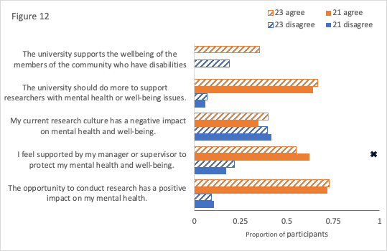

In the 2021 survey, the influence of the Covid-19 pandemic was acknowledged as one of the factors impacting on mental health.

**2021**

*“Workload was a huge problem before Covid hit. Afterwards (and especially for those with caring responsibilities) the workload has been completely unsustainable. While home schooling, I have been sleeping just 5 hours a night to try and get my work done in the evenings and early mornings (and even then, there is a terrible backlog building up) and the stress has caused regular heart palpitations and stomach acid problems. The challenges will not go away the minute children are back in school. Staff with caring responsibilities will have built up huge backlogs of work and will also have spent the last 12 months pulling out of conference papers/articles and saying no to future commitments, in an effort to catch up. This will have negative impacts on future promotions as well as being a source of immediate stress.”*

**Woman, undisclosed ethnicity, 40-49, Education & Research, AD**

In the 2023 survey, mental health support and workload were topics commented on most frequently, with education and research-focused and education-focused participants mentioning time pressures and pressure of workload more than other groups. The impact of precarious work contracts was also highlighted.

**2023**

*“In general, doing research has a positive impact on my mental health, as it is something that I love doing. However, with current teaching and admin workloads and the pressures of obtaining funding I do not have sufficient time to do my research properly within my working hours. That I am still expected to 'ever excel' has a negative impact on my mental health.”***Woman, White, 40-49, Education & Research, SM**

*“It would be great if there were mental health and well-being resources specifically aimed at researchers with temporary contracts. While doing research gives me a sense of fulfilment and joy, pressure to succeed and insecurity about the future has a negative impact on my mental health. I feel like these struggles specific to early career researchers without job security should be acknowledged more. Conducting research at the UStA is a privilege but that doesn't mean job insecurity does not affect me.”*

**Non-binary, White, 30-39, Research-Focused, SM**

**2.5 Bullying & Harassment**

In terms of safety and dignity at work, similarly high proportions of participants across the years are aware of the policies on dignity and inclusion, and bullying and harassment (Figure 11), yet fewer in 2023 knew where to report concerns.

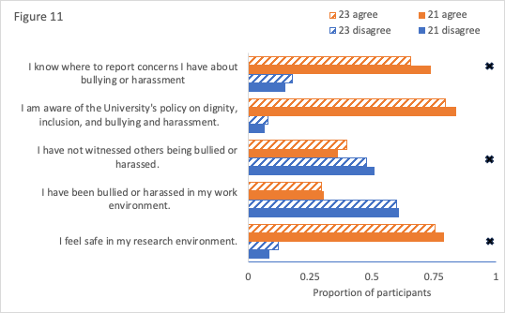

More people report having witnessed others being bullied or harassed in 2023, and although though there is no increase reported in participants themselves being bullied or harassed, significantly smaller proportion of people felt safe in their research environment.

Participants in both surveys commented that researchers continue to feel unsupported and unable to speak about experiences of harassment or bullying.

In the 2021 survey, the Report & Support system had just been introduced and participants expressed a lack of trust in the system.

**2021**

*“It is all well and good to have policies, but ultimately you one way to judge if things are improving is to assess whether people feel confident to call out discrimination without fear of back-firing.”*

**Woman, White, 30-39, Research-focused, SM**

*“The university claims to have a zero-tolerance policy on bullying and harassment. But the "rights" of perpetrators are protected more than the rights of victims. Processes that give perpetrators second chances and a pathway to "reform" themselves also undermine victim wellbeing and the safety of the community.”*

**Man, White, 30-39, Education & Research, SM**

In the 2023 survey participants also expressed concerns and dissatisfaction with the system.

**2023**

*“I only heard about the report and support scheme a couple of weeks ago and was shocked that it is not publicized more widely.”*

**Woman, White, 20-29, Research-Focused, SM**

*“This is a tough question. The Uni has report-and-support systems in place for this, but I know personally of people who do not trust the system, and do not report. Perhaps the Uni needs to work on how to encourage trust and a more open reporting environment.”*

**Woman, White, 50-59, Education & Research, SM**

Participants also expressed wider concerns about the complaints process in general.

*“Given my knowledge of a range of cases of bullying/harassment I would consider very carefully - and advise others - to think about whether it's worth raising any cases of bullying/harassment with the University since 1) it's very distressing to victim ; 2) opens victim up to further bullying form the aggressor and 3) I don't see the university as having effective processes/motivation for dealing with bullies. Given that, it may be best just to put up with it or move institution. Note that bullies themselves sometimes use the bullying procedure to allege that their victims are bullying them - another form of bullying - and the university doesn't seem to be adequately aware of this.”*

**Woman, White, 20-29, Education & Research, AD**

## **2.6 Work-Life Balance**

Work-life-balance responses were very similar across the two years, with improvement in the questions only around the impact of Covid-19, and that research was a more rewarding experience in 2023 (Figure 13).

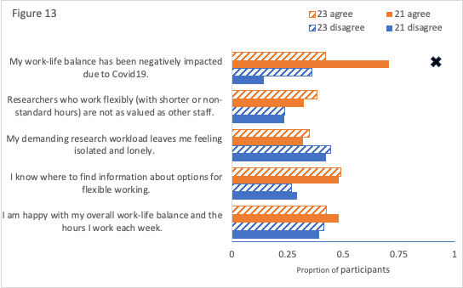

Figure 13 shows that there has been no improvement in feelings that overall work-life balance is good, nor any evidence in reduction in feeling of isolation, or pressure and stress

In the 2021 survey, participants from all job families said they felt under pressure to deliver against research expectations from the UStA. In the 2023 survey, older participants (50+) expressed more agency in relation to their work-life balance, making choices around how they engaged with UStA. Younger participants in the 2023 survey made references to looking for options out with academia.

In the 2023 survey, it was clear that Covid-19 has had long-term impacts on work-life balance. The 2021 survey participants felt that during the pandemic teaching was prioritised over research. In the 2023 survey participants felt that UStA’s commitment remains with teaching, with research pushed behind teaching in terms of university’s commitments and resources.

**2021**

*“Because research has been so severely curtailed by lockdowns and physical distancing, and by the focus from the University of teaching (which has been overwhelming in many cases) there have been frustrations.”*

**Man, undisclosed ethnicity, 50-59, Education & Research, SM**

**“***Pressures to develop new ways of teaching and support of students has taken huge amounts of time away from research. Expectations in these areas must be eased so that research time can be won back.”*

**Undisclosed Gender and ethnicity, 20-29, Research Student, AD**

**2023**

*“I force the issue of work life balance by only working physically from my office. CV19 forced me to work from home with the result there was no boundary on how much I had to work. Also there was no understanding that parents had children sent home who needed to be entertained and supported.”*

**Man, White, 50-59, Education & Research, SM**

*“The pattern seems to be that as teaching and admin workloads grow, research time shrinks.”*

**Man, Mixed Ethnicity, 40-49, Education & Research, SM**

*“I worked almost every weekend beginning in August 2020 due to increased workload pressures so as to continue research. The increased pastoral needs of students and the increased expectations on teaching materials (i.e. availability of slides, lecture recordings, teaching materials in advance, etc.) has increased the pressure on staff considerably but nothing has been removed from our other duties nor have more staff been hired so that the load could be spread out. We cannot help but do less research or push ourselves to extremes as a result.”*

**Woman,** **White, 40-49, Education & Research, AD**

## **2.7 Research Satisfaction**

There were differences between the 2021 and 2023 answers on research satisfaction. In 2023, research satisfaction was higher, and the impact of Covid-19 appears to have reduced.

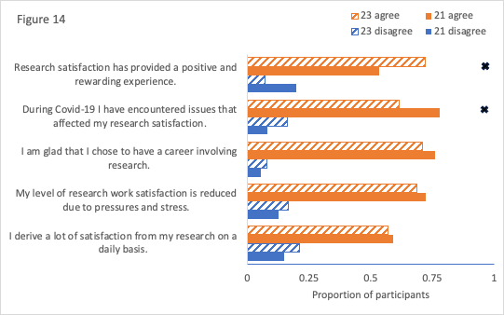

In both 2021 and 2023 surveys, a lack of time for research was highlighted as the biggest challenge to research satisfaction.

**2021**

*“I love my research and it gives me the greatest satisfaction. The issue, at least for me, is that the university creates a working environment that hinders, rather than supports, the conduct of research due to constantly increasing demands on my time and energy.”*

**Man, undisclosed ethnicity and age, 20-29, SM**

*“If I could spend more time on research, I would have more job satisfaction, better mental health, and a better work life balance. However, due to excessive workload for other aspects of the job (teaching/admin), the research takes a back seat, causing stress and the feeling of a stagnating career.”*

**Undisclosed gender, ethnicity and age, Education & Research, SM**

**2023**

*“I love research and I derive immense amounts of satisfaction from it. Yet, with the multiple work demands, the very different time frames and diverse modes of working that I now experience, my work life involves 'issues' that cause frustration, desperation, and exhaustion.”*

**Woman, White, 40-49, Education & Research, AD**

## **2.8 Leadership**

Leadership is the theme of a recent successful funding bid from the Wellcome Trust, and may therefore be of particular interest in relation to our findings. Our data suggest some key areas for improvement in this area. A minority of participants across both years felt that they experienced good research leadership (Figure 15), and fewer felt they have been managed well in 2023 than 2021. Few agree that sufficient support is provided to deliver good leadership (this is significantly worse in 2023 than 2021), with many feeling that research is not always led by those with good leadership skills. A large majority agree across both years that investigators should be trained to deliver leadership.

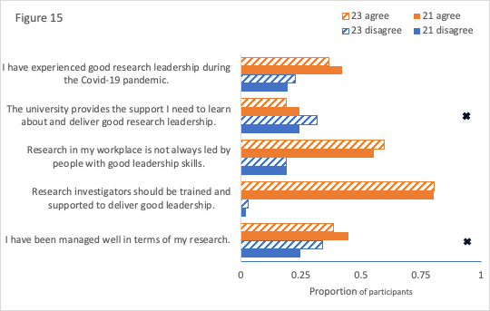

The 2021 survey produced more positive comments around the topic of leadership than in the 2023 survey. The lack of diversity and a feeling of distance between senior leadership and the rest of UStA was referenced in similar ways in both surveys. The lack of training for Heads of School and supervisors was referenced more in the 2023 survey. The need to improve training for leadership across the UStA was mentioned by all groups in the 2023 survey.

**2021**

*“Leadership seems to me to be collective and to come from groups of people, or people working with a strong sense of their being part of a group. I've been responsible for some forms of research leadership during COVID and the REF. I felt that many of my colleagues, regardless of age in career or research area, initiated valuable, collective research activities over the last year or so, and helped to support and lead others - often colleagues who have been in post longer.”*

**Man, White, 40-49, Education & Research, AD**

*“Current research culture still often seems at least initially to promote people based mainly on individual success in areas such as publishing and securing funding. Leadership/ management then often seems to be a matter of learning on the job while at the same time as continuing individual research, teaching etc…. the process would likely work better with additional training and better recognition of the time required for those aspects of any new position.”*

**Man, undisclosed gender, 50-59, Professional Services, SM**

**2023**

*“The research output is the university's main concern. Other considerations such as leadership is of significantly lesser importance.”*

**Man, White, 30-39, Research-Focused, SM**

*“The isolation is visible, colleagues do not drop in as they did years ago, asking how things are. Managers never drop in or make appointments to help you further your career goals. There's total absence at the manager level to address the unbalance of BAME promotion beyond the junior level. Instead, various excuses were often given to the absence of such BAME colleagues.”*

**Non-binary, undisclosed ethnicity, 50-59, Education & Research, SM**

*“Leadership is something that should be developed from PhD-students onwards. Most Uni environments assume leadership starts with PI's and Heads of School. This is a blinkered approach, not common in other areas of work. We should ALL be offered training in leadership.”*

**Woman, White, 50-59, Education & Research, SM**

## **2.9 Sustainability**

This was an open question in the 2023 survey that did not appear in 2021. Sustainability was mentioned by 1 participant in the 2021 survey. There were 36 responses to the open question on sustainability in 2023, “How could research culture support the St Andrews [sustainability aims](https://www.st-andrews.ac.uk/sustainability/vision/)?". Most groups felt the University shows a lack of commitment to sustainability by not implementing sustainable research practices. Some older researchers (50+ yrs.) felt that air travel and travel generally is an essential part of research while younger participants felt that the propensity to travel should be reduced, and that researchers should be making more effective use of Teams and other digital platforms.

**2023**

*“Training in good/sustainable lab practices that staff can pass on to students, especially project students, on a day-to-day basis.”*

**Non-Binary, undisclosed ethnicity, 30-39, Research-Focused, undisclosed discipline**

***“****Stop paying expenses for flights under any circumstances. We have Zoom and teams now, there is very little reason for intra/international flying.”*

**Man, undisclosed ethnicity, 20-29, Research Student, undisclosed discipline**

“*The tail must not wag the dog - sustainability aims should not impact research. This is tricky as some staff members need to travel substantially for their work. Uni can help offset some of the energy costs and C foot print I think by make the older buildings more energy efficient*.”

**Man, undisclosed ethnicity, 50+, Education & Research, undisclosed discipline**

*“It still feels like we have not had open conversations about how academia should change in response to climate change. We should travel less...but we need to boost the Uni's world-wide status. I have not seen groups of people talking about how we make real changes that can support our future, without penalising those willing to engage when their CV's look less impressive than those who wander about the world at will burning carbon like there's no tomorrow.”*

**Woman, undisclosed ethnicity, 50+, Education & Research, undisclosed discipline**

# **3.0 Conclusions and Next Steps**

The most striking aspect of a comparison between the results of the 2021 and 2023 surveys was how similar the results were, suggesting that the areas that need work in the research culture domain remain static. Similarly, areas where the University is doing well, have also been retained across the two periods.

The findings from both the 2021 and 2023 surveys suggest there have been no measurable changes to UStA research culture during this period on the topics of interdisciplinarity, collegiality, and collaboration. Across both time periods, participants consistently identified research integrity as an area of strength for the University.

There were variations between 2021 and 2023 surveys in relation to EDI, bullying and harassment, wellbeing and career development. The 2023 survey provided a less positive picture on these topics, with more people showing awareness of discrimination, fewer people agreeing that University policies are improving EDI, and less people feeling training opportunities were appropriate to their needs.

In relation to mental health and wellbeing, the 2021 survey highlighted Covid-19 as a huge factor, while 2023 responses focused on time and workload pressures not directly relating to the pandemic as impacting on mental wellbeing.

The 2023 survey also showed approaches to work-life balance differing across age ranges, with older participants (50+) expressing more agency in how they managed their work-life balance while younger participants mentioned considering work outwith academia. These findings may also link to concerns around the prevalence of precarious work contracts among younger academics (Royal Society 2021) and the lack of recognition for contributions by temporary or non-academic staff (Morton 2022) that have been identified across wider academic research cultures.

A key concern highlighted by all groups within the 2023 survey was a need to improve leadership training for Heads of Schools, PIs, and Supervisors. This will hopefully be addressed through the forthcoming Collegial Leadership project funded through the Wellcome Trust. As part of the Collegial Leadership project, it may be helpful to consider governance of research culture within UStA to maximise the potential for levers of change and provide traceable impact. Research (and indeed Institutional) Culture is a huge area, covering many aspects of our work environment. At the current time the responsibility for research culture within UStA sits with VPRes and Research and Innovation Service (RIS). This fits well for aspects relating to integrity, open research funding and performance measures but could benefit from closer, more formal, ties to other aspects of research culture linked to recognition and reward, workforce development, bullying and harassment, wellbeing and EDI that align more closely with other organisational structures (HR, EDI, OSDR).

# **References**

Department of Science, Innovation and Technology and Department for Business, Energy & Industrial Strategy 2021 Research and Development (R&D) People and Culture Strategy, <https://www.gov.uk/government/publications/research-and-development-rd-people-and-culture-strategy>

Carusi A. (2024) Wellcome’s 2019 funding for PhD programme training: An experiment in enhancing research culture [version 1; peer review: awaiting peer review], *Wellcome Open Res 2024,* ***9****:224* (<https://doi.org/10.12688/wellcomeopenres.21052.1>)

Hosseini, M., Gordijn, B., Wafford, Q. E., & Holmes, K. L. (2023). A systematic scoping review of the ethics of Contributor Role Ontologies and Taxonomies. *Accountability in Research*, 1–28. <https://doi.org/10.1080/08989621.2022.2161049>

Macfarlane, B. and Jefferson, A.E. (2022) The closed academy? Guild power and academic social class, *Higher Education Quarterly, 76:36-47*

Morton, L. (2022) What author order can (and cannot) tell us: Understanding Contributorship, *The Official PLOS Blog January 18, 2022* [[*https://theplosblog.plos.org/2022/01/contributorship/*](https://theplosblog.plos.org/2022/01/contributorship/)](https://theplosblog.plos.org/2022/01/contributorship/)

Research England (2022) Enhancing research culture funding allocations 2022-2023 <https://www.ukri.org/publications/enhancing-research-culture-funding-allocations-2022-to-2023/>

REF29 People, Culture and Environment <https://www.ref.ac.uk/people-culture-and-environment-pce/>

Royal Society (2021) The Research and Technical Workforce in the UK, Policy Briefing February 2021 <https://royalsociety.org/-/media/policy/Publications/2021/2021-02-12-research-and-technical-workforce-in-the-uk.pdf>

Russell Group (2021) Realising Our Potential: Backing Talent and Strengthening UK Research Culture and Environment. <http://realisingourpotential.russellgroup.ac.uk/>

UKRI (2024) Future Leaders Development Network [Future Leaders Development Network](https://www.bing.com/ck/a?!&&p=aca785b00c50ca41JmltdHM9MTcxNjE2MzIwMCZpZ3VpZD0zNWE0ZTNkNS0zM2Q5LTZkZDgtMzg2NS1mMmY4MzI4MTZjOTAmaW5zaWQ9NTIxOA&ptn=3&ver=2&hsh=3&fclid=35a4e3d5-33d9-6dd8-3865-f2f832816c90&psq=future+leaders+development+netwrok&u=a1aHR0cHM6Ly93d3cuZmxmZGV2bmV0LmNvbS8&ntb=1)

UKRN Open and Responsible Research Project 2022-2026 <https://www.ukrn.org/open-and-responsible-researcher-reward-and-recognition-or4/>

Wellcome Trust 2023 Institutional Funding for Research Culture (IFRC) <https://wellcome.org/grant-funding/people-and-projects/grants-awarded/institutional-funding-research-culture-ifrc>

1. Collegiality and Competition; Equality, Diversity and Inclusion (EDI); Interdisciplinarity; Research Integrity; Mental Health and Wellbeing; Work-Life Balance; Research Satisfaction; Leadership; Sustainability.
2. Identifiers relate to those in Figures 3 and 4 above relating

   to gender, ethnicity, age range, discipline and job family. Some labels have been redacted to preserve anonymity of participants.